RESOLUTION NO.__________

RE: CERTIFICATE OF APPROPRIATENESS UNDER THE
PROVISIONS OF THE ACT OF THE PENNSYLVANIA
LEGISLATURE 1961, JUNE 13, P.L. 282 (53
SECTION 8004) AND BETHLEHEM ORDINANCE NO.
3952 AS AMENDED.

WHEREAS, it is proposed to install new roof and gutters and restore the chimney at 917 Prospect Ave.

NOW, THEREFORE, BE IT RESOLVED by the Council of the City of Bethlehem that a Certificate of Appropriateness is hereby granted for the work.

Sponsored by: (s)

(s)

ADOPTED BY COUNCIL THIS DAY OF

(s)
President of Council

ATTEST:

(s)
City Clerk

HISTORIC CONSERVATION COMMISSION

CASE # 389 – It is proposed to install new roof and gutters and restore the chimney at 917 Prospect Ave.
OWNER/APPLICANT: Michael & Carolyn Facchiano

The Commission upon motion by Mr. Evans and seconded by Mr. Roeder adopted the proposal that City Council issue a Certificate of Appropriateness for the proposed work described herein:

- The proposal to install new roof and gutters and restore the chimney at 917 Prospect Ave. was presented by Carolyn Facchiano.

- The deteriorated and storm-damaged slate roof will be replaced with GAF Slateline shingles in the Antique Slate color on both the porch and main house.

- The gutters and downspouts will be replaced with new galvanized half round gutters and round downspouts.

- New flashings will be copper and drip edges will be either copper or cream color to match the trim. Step flashing is recommended at the chimney.

- The existing deteriorated chimney will be rebuilt with new brick that matches the sample brought to the meeting. It was requested that the name and manufacturer of the brick be submitted to become part of the record.

- The pointing mortar used in rebuilding the chimney should match the historic mortar in color, texture, joint style, and composition as closely as possible. The mortar should have an appropriate high-lime content.

- The proposed work was unanimously approved.

CU: cu

By: 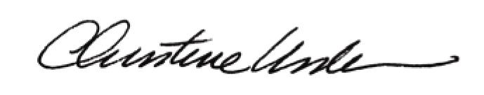

Date of Meeting: September 19, 2011 Title: Historic Officer

